Core Criterion and Core Evidence Vocabulary
Version 1.0.0

Document Metadata
Date | 2016-12-15
Rights | © 2016 European Union
Licence | ISA Open Metadata Licence v1.1, retrievable from https://joinup.ec.europa.eu/category/licence/isa-open-metadata-licence-v11
Access URL | https://joinup.ec.europa.eu/node/157823

This study was prepared for the ISA Programme by:
PwC EU Services
Disclaimer:
The views expressed in this report are purely those of the authors and may not, in any circumstances, be interpreted as stating an official position of the European Commission.
The European Commission does not guarantee the accuracy of the information included in this study, nor does it accept any responsibility for any use thereof.
Reference herein to any specific products, specifications, process, or service by trade name, trademark, manufacturer, or otherwise, does not necessarily constitute or imply its endorsement, recommendation, or favouring by the European Commission.
All care has been taken by the author to ensure that s/he has obtained, where necessary, permission to use any parts of manuscripts including illustrations, maps, and graphs, on which intellectual property rights already exist from the titular holder(s) of such rights or from her/his or their legal representative.

Contents
1. Introduction 1
1.1. Context and problem statement 1
1.2. Proposed solution 2
1.3. Scope 2
1.4. Process and methodology 2
1.5. Structure of this document 3
2. Existing solutions 5
2.1. The European Single Procurement Document 5
2.2. CEN BII Data Models 6
2.3. Core Person Vocabulary (CPV) 6
2.4. Core Public Organisation Vocabulary (CPOV) 7
2.5. Core Public Service Vocabulary 8
2.6. Dublin Core DCMI Type Vocabulary 9
2.7. The W3C Organisation Ontology 9
3. Use cases 10
3.1. Facilitate development of interoperable information services 10
3.2. Create a repository of reusable criteria in machine-readable formats 10
3.3. Automate the assessment of criteria 11
3.4. Automate scoring of responses 11
3.5. Promote cross-border participation in public procurement 11
3.6. Calculating statistics 12
3.7. Enable comparability of evidences through criteria mapping 12
4. Requirements 13
5. Core Criterion and Core Evidence Vocabulary 15
5.1. Data Model for the CCCEV 15
5.2. Class: Criterion 15
5.2.1. Property: identifier 16
5.2.2. Property: criterion type 16
5.2.3. Property: name 16
5.2.4. Property: description 16
5.2.5. Property: fulfilled indicator 16
5.2.6. Property: weight 16
5.2.7. Property: is defined in Formal framework 16
5.2.8. Property: fulfilled by Requirement group 16
5.3. Class: Formal framework 16
5.4. Class: Requirement group 17
5.4.1. Property: identifier 17
5.4.2. Property: description 17
5.4.3. Property: has Criterion requirement 17
5.5. Class: Criterion requirement 17
5.5.1. Property: identifier 17
5.5.2. Property: name 18
5.5.3. Property: description 18
5.5.4. Property: expected data type 18
5.5.5. Property: expected value 18
5.5.6. Property: maximum value 18
5.5.7. Property: minimum value 18
5.5.8. Property: type of translation 18
5.5.9. Property: level of certification 18
5.5.10. Property: type of copy quality 18
5.5.11. Property: applicable in Period of time 18
5.5.12. Property: met by Evidence 18
5.6. Class: Requirement response 18
5.6.1. Property: identifier 19
5.6.2. Property: name 19
5.6.3. Property: description 19
5.6.4. Property: value 19
5.6.5. Property: applies to Period of time 19
5.6.6. Property: validates Criterion requirement 19
5.6.7. Property: proven by Evidence 19
5.7. Class: Period of time 19
5.7.1. Property: start time 19
5.7.2. Property: end time 19
5.8. Class: Evidence 19
5.8.1. Property: identifier 20
5.8.2. Property: evidence type 20
5.8.3. Property: name 20
5.8.4. Property: description 20
5.8.5. Property: language 20
5.8.6. Property: issued by Organisation 20
5.8.7. Property: is supported by Document reference 20
5.8.8. Property: belongs to Agent 20
5.9. Class: Agent 20
5.9.1. Property: satisfies Criterion 20
5.9.2. Property: provides Requirement response 20
5.10. Class: Organisation 21
5.11. Class: Person 21
5.12. Class: Document reference 21
5.12.1. Property: identifier 21
5.12.2. Property: URL 21
5.12.3. Property: description 21
5.12.4. Property: type 21
5.13. RDF distribution of the CCCEV 21
6. Examples 22
6.1. Simple examples 22
6.2. Exclusion criterion 23
6.2.1. Criterion 23
6.2.2. Formal framework 24
6.2.3. Requirement group 25
6.2.4. Criterion requirement 25
6.2.5. Requirement response 27
6.2.6. Evidence 30
6.2.7. Document reference 31
6.3. Selection criterion 31
6.3.1. Criterion 31
6.3.2. Requirement group 31
6.3.3. Criterion requirement 32
6.3.4. Period 33
6.3.5. Requirement response 33
7. Conformance Statement 35
8. Accessibility and Multilingual Aspects 36
9. References 37

List of Figures
Figure 1: ESPD Data model 6
Figure 2: Data model for the CPOV 8
Figure 3 Data model for the CPSV 9
Figure 4 CCCEV Data model 15

List of Tables
Table 1: Process and Methodology Overview 3

Introduction

Context and problem statement
Decision-making is one of the most common activities within the public sector that span across all different public processes, operations and services. In some cases, decisions are based on intuition, in other cases on evidence or on a combination of both. For an official decision to be made in the public sector, a set of criteria, which usually derives from legislation, have to be assessed and fulfilled by some agent. This agent can support the statement that he meets the criterion with specific pieces of evidence, which are usually documented in administrative documents and base registries. For example, an official decision has to be made in order to purchase new equipment for hospitals, to hire new staff, to contract a new study, or to give a grant to a newly found business.

Take for instance the case of public procurement, which includes selecting eligible bidders in an electronic tendering process, assessing the bids and scoring them, or excluding a candidate for a specific position. All these processes involve a requestor setting criteria, and the parties willing to participate reply with specific evidences, which they believe that prove their capability to fulfil the criteria. The requestor assesses the responses either accepting or rejecting them, and scores each response to finally select the most suitable based on the criteria and the provided evidences.

Despite being broadly used across organisations, sectors and borders, data about criteria and evidences is not harmonised and is understood differently in different contexts. Returning back to the example of public procurement, the following challenges are hampering the automated processing and the reuse of data about criteria and evidences:

- Complex environment: Data about criteria and evidences is found in many different sectors and countries, which often define and represent them differently. As the number of cross-border (or cross-sector) exchanges of data increases, there is a need to harmonise the criteria and evidences in order to work towards a Digital Single Market.
- Number of actors involved: There are many different actors involved. Not only the sender and the receiver but also third parties providing evidentiary documentation. These parties are often in different levels of technical maturity.
- Large number of types of evidences: There are many different types of evidences and procedures can require to deliver these documents under the consideration of different types of quality attributes ranging from candidate statements to very formal procedures (notarization, legalization, apostil, certified translation, certified copy)

Proposed solution
By using the Core Criterion and Core Evidence Vocabulary (CCCEV), public organisations have the potential to implement new capabilities in their information systems to:

- Allow the use of criteria from common repositories, standardising the criteria used in different sectors and domains.
- Enable the automatic response to criteria, lowering the language barrier for cross-border processes and exchanges.
- Enable the automatic assessment through the analysis of criteria and provided evidences.
- Promote the standardisation of criteria and evidences among attestation and certificate providers, and across different Member States.
- Increase the transparency of the assessment and therefore the selection processes, reducing complaints and subjective assessment.

Section 2 describes a set of use cases that can benefit from the CCCEV.

Scope
The CCCEV contains two basic and complementary core concepts:

- the criterion, something used as the basis for making a judgement or decision, e.g. a requirement set in a public tender or a condition that has to be fulfilled for a public service to be executed; and
- the evidence, something which proves that something else exists or is true, in particular an evidence is used to prove that a specific criterion is met by someone of by something.

Wherever possible, the CCCEV will reuse existing vocabularies and, as a result, may not define any new terms of its own. It will define how existing terms should be used and may suggest specific code lists to be used as values for specific properties.

It is not within the scope of the CCCEV to create user interfaces such as web forms in order to gather information from the contracting authorities or from the economic operators on criteria or evidences but to define the semantic concepts and their relationships.

Process and methodology
This common data model has been defined as a core vocabulary for criteria and evidences. A Core Vocabulary is a simplified, reusable, and extensible data model that captures the fundamental characteristics of an entity in a context-neutral fashion. Well-known examples of existing Core Vocabularies include the Dublin Core Metadata Set.

Such Core Vocabularies are the starting point for agreeing on new semantic interoperability assets and defining mappings between existing assets. Semantic interoperability assets that map to or extend such Core Vocabularies are the minimum required to guarantee a level of cross-domain and cross-border interoperability that can be attained by public administrations.

The work has been conducted according to the ISA process and methodology for developing Core Vocabularies [2]. The process and methodology provides guidance in two domains. First, the process describes how consensus can be reached among stakeholders and domain experts so that the vocabulary is recognised as meeting its design goals, leading to endorsement by Member States. Second, the methodology describes how the core vocabulary is specified following best practices for selecting, reusing, developing and presenting concepts. Table 1 provides an overview of the steps in the process and methodology.

A project has been created on Joinup for facilitating the development of the Criterion and Evidence Core Vocabulary: https://joinup.ec.europa.eu/node/148216.

Table 1: Process and Methodology Overview
Process  Reaching consensus | Methodology  Developing a specification
- Identify stakeholders  - Form working group  - Identify chair & co-chair  - Identify editors  - Form review group  - Secure IPR  - Establish working environment and culture  - Publish drafts  - Review drafts  - Publish last call working draft  - Review last call working draft  - Gather evidence of acceptance  - Submit for endorsement  - Endorse | - Identify a meaningful set of Core Concepts  - Research and review existing solutions  - Research existing data and services  - Use cases  - Requirements  - Terminology and conceptual data model  - Naming conventions  - Identifier conventions  - The namespace document  - Quality Assurance & Conformance Criteria

Structure of this document
This document consists of the following sections.

- Section 2 describes the existing solutions, data models and ontologies that refer to the criteria and evidences
- Section 3 defines the main use cases that drive the specification of the Core Vocabulary.
- Section 4 collects the information requirements for criteria and evidences.
- Section 5 identifies the classes and properties defined for the vocabulary.
- Section 6 contains examples that illustrate the use of the CCCEV.
- Section 7 contains the Conformance Statement for this Core Vocabulary.
- Section 8 describes specific accessibility and multilingualism aspects.
- Section 9 contains related references.

Existing solutions
This specification is based on different initiatives and projects that have been working on the modelling of Criteria and Evidences.

The European Single Procurement Document
On January 2016, the European Commission adopted the European Single Procurement Document (ESPD), a document that will considerably reduce the administrative burden for companies, in particular SMEs who want to have a fair chance at winning a public contract.

The ESPD will allow all businesses to electronically self-declare that they meet the necessary regulatory criteria or commercial capability requirements, and only the winning company will need to submit all the documentation proving that it qualifies for the contract (Europa, 2016).

In order to make full use of the ESPD concept, the European Commission will establish a set of services available for both suppliers and buyers. The initial service is e-Certis, a system where the Member States will declare which evidences can be used to prove a fulfilment of a criterion depending on the Member State where the economic operator is located. As a second step, the European Commission will provide the ESPD service that will use e-Certis to help the contracting authorities and economic operators creating the criteria and evidence documents allowing them to participate in electronic tendering procedures across Europe. The ESPD service will be free of charge to Member States and European Institutions. It will be provided as open source. Service providers will be able to implement it for their own use to provide added value to buyers and suppliers (EC Europa: EUROPEAN SINGLE PROCUREMENT DOCUMENT SERVICE).

In conclusion, the main objective of the ESPD is to reduce the administrative burden for buyers and suppliers to participate in public procurement procedures. The ESPD service will reduce that burden by providing qualification criteria and qualification evidences for participating in a public procurement process.

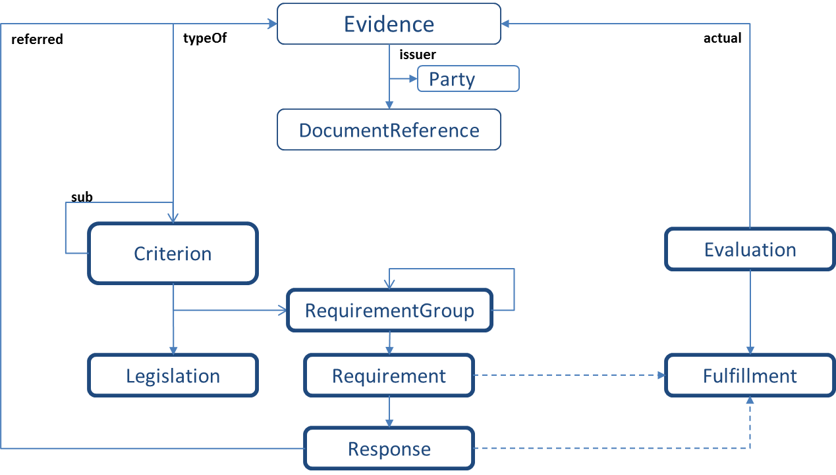
Figure 1: ESPD Data model

CEN BII Data Models
The CEN Workshop on business interoperability interfaces for public procurement in Europe (CEN WS/BII) was established in March 2007. The CEN Business Interoperable Interfaces Workshop Agreements have defined Profiles that describe process choreographies between two parties that exchange information using business transactions. These business transactions provide, among others, classes representing reference criteria, essential competence requirements and criteria responses.

The CEN WS/BII profiles have already been implemented in several projects in Europe: The European Commission has used them to build e-Prior, their open source solution for electronic invoicing, ordering and now covering the pre-award phases of electronic procurement.

The PEPPOL community has used them to create their own BIS specifications, resulting in a national-wide and cross-border deployment of electronic invoicing in countries such as Norway, Denmark or Sweden, and new governments in Europe are currently basing their IT infrastructure and electronic procurement policies on deploying these standards such as the National Health Service of England.

Core Person Vocabulary (CPV)
The Core Person Vocabulary is one of the three Core Vocabularies developed in the context of Action 2.1 of the Programme of the European Commission.

The Core Person Vocabulary is a simplified, reusable and extensible data model that captures the fundamental characteristics of a person, e.g. the name, the gender, the date of birth, the location.

The Core Person Vocabulary defines terms and classes that will be reused in the CCCEV.

Core Public Organisation Vocabulary (CPOV)
In 2016, the ISA2 Programme of the European Commission developed the Core Public Organisation Vocabulary (CPOV) for supporting the exchange of basic information about individual public organisations. The CPOV is designed to describe the organisation itself. Whilst the vocabulary may support links to descriptions of services it operates, members of staff or other resources such as relevant legislation, policies and jurisdictional coverage.

The Core Public Organisation Vocabulary defines terms and classes that can be reused in the CCCEV. The “Public Organisation” class of the CPOV could be used for defining the organisations that are issuing the evidences for conforming to the declared criteria.
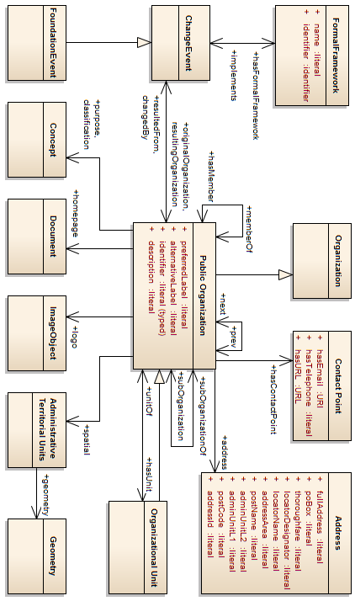
Figure 2: Data model for the CPOV

Core Public Service Vocabulary
The Core Public Service Vocabulary allows public administrations to describe their services only once using a standard, extensible, and machine-readable vocabulary and makes these descriptions re-used on many governmental access portals.
This Core Public Service Vocabulary defines terms and classes that can be reused in the CCCEV. The legal terms that drive the definition of a criterion can be classified under the “Formal Framework” class of the CPSV.
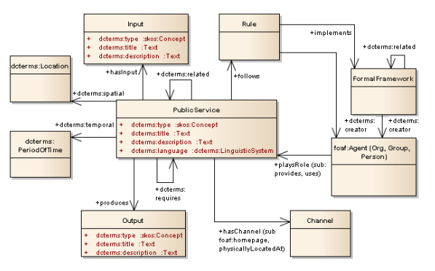
Figure 3 Data model for the CPSV

Dublin Core DCMI Type Vocabulary
Initially developed in 2002, the DCMI Type Vocabulary provides a general, cross-domain list of approved terms that may be used as values for the Type element to identify the genre of a resource. Type includes terms describing general categories, functions, genres, or aggregation levels for content.
Evidences are resources and can have associated metadata. The DCMI Type Vocabulary can be used for providing a list of evidences that can be submitted for satisfying a specific criterion.

The W3C Organisation Ontology
Initially developed in 2010 for the UK government, the Organisation Ontology became a W3C standard in January 2014 and has been widely used elsewhere. It meets all the requirements, however, this is only so if it is used in a particular way, notably if different organisations use common code lists as values, in particular, for properties such as org:classification and org:purpose.

The Organisation Ontology describes a core ontology for organisational structures, aimed at supporting linked data publishing of organisational information across a number of domains. It is designed to allow domain-specific extensions to add classification of organisations and roles, as well as extensions to support neighbouring information such as Organisational activities.

Use cases
The Core Criterion and Core Evidence Vocabulary (CCCEV) is designed to meet specific needs of public administrations, businesses and citizens across the European Union. These needs are described in the use cases below.

Facilitate development of interoperable information services
Services dealing with criteria and evidences are often based on manual processes. A Core Vocabulary for describing criteria and evidences can drive the development of new information systems to support different public processes and services, including:

- Public procurement information systems where criteria for selection and exclusion of candidates and awarding criteria could be defined.
- Pre-qualification systems that can be used to manage lists of pre-approved economic operators.
- e-Tendering platforms facilitating the link between the criteria defined by the public Organisations and the responses and evidences from private bidders.
- E-learning systems that could use criteria and criterion responses to define and evaluate exams for the students.
- HR systems where candidates and their qualifications could be stored and analysed using this common standard.
- Systems assessing grants, where the grantor sets a list of criteria participants need to fulfil in order to be eligible.

 | The CCCEV allows services to seamlessly exchange information about criteria and evidences related not only to public procurement development but also to the provision of digital public services in general.

Create a repository of reusable criteria in machine-readable formats
Standardising criterion and evidence models allows for the creation of lists of criteria and evidences. These lists of criteria and evidences can be created according to the needs of different domains, sectors or countries, but as they use this Core Vocabulary, they can be compared and merged into standardized code lists to cover global scenarios. Some of these lists can be reused by different Organisations following a similar process. To maximise reuse, criteria should be encoded in machine-readable formats.

An example could be the European Single Procurement Document, where a collection of standardised criteria is created and exchanged with potential tenderers in order to assess whether they can be qualified.

 | The CCCEV enables the creation of a repository of criteria and evidences which can be reused in different public procurement cases and digital public services.

Automate the assessment of criteria
Nowadays, most of the assessment processes are done manually, gathering responses and individually scoring or assessing them. This activity is time-consuming, error-prone and could be seen as non-transparent.

The formal language for criteria and evidences defined by the CCCEV would allow the creation of systems capable of treating the criteria responses and evidence data automatically, which would facilitate the objective and automatic assessment support for people assessing or qualifying.

 | The CCCEV can help e-Government and e-Procurement systems to easily compare the information collected from different parties and enables automatic assessment of the responses to a specific criterion.

Automate scoring of responses
When criteria are weighted, criterion responses could be ordered by the receiving systems. This use case is relevant for instance in electronic tendering when assessing criteria are defined with their own weight. The receivers of the criterion responses shall assess and order them according to their level of compliance to the defined criteria and their weight.

The Core Vocabulary can help systems ordering the received responses based on the automatic assessment of the received criterion responses after applying the assigned weight.

 | Taking the previous scenario one step further, by assigning weights to criteria, the assessment can be followed by an automate scoring of the responses provided by different parties.

Promote cross-border participation in public procurement
Cross border processes in Europe have the challenge of the different language domains. There are multiple languages in Europe, and for criterion-response processes to be deployed cross-border, criteria should be understood despite the language of the receiver.

The Core Vocabulary allows for the creation of standardized coded lists of criteria. These standardised coded lists of criteria can be translated into different languages, having the potential to lower the language barrier for cross-border business processes, and increase the transparency of the qualification processes.

 | The CCCEV allows for increase transparency of qualification processes improving the cross-border exchange of information, and thus the cross-border participation in pan-European selection processes.

Calculating statistics
Statistical offices can gather information and generate accurate statistics using the formally defined criteria and evidences through this Core Vocabulary. They can collect structured information from public repositories such as the Publications Office and analyse the most used criteria, the number of criteria defined for a particular type of process or even identify criteria preventing participation.

High quality statistics can help driving policies on electronic public procurement or other sectors where criteria and evidences have special relevance.

 | By standardising data for criteria, criterion responses and evidences, public administrations, auditors and independent organisations can calculate statistical information on the most common used criteria for a given process, the most relevant evidences, etc.

Enable comparability of evidences through criteria mapping
The Core Vocabulary enables the creation of a registry of mappings of criteria in different countries and jurisdictions. Enabling comparability of evidences eases cross border services.
For example, a specific criterion in one member state can be fulfilled by an organisation providing two different evidences. However, an organisation from another member state is not able to provide neither of these two evidences, as they are country-specific. Organisations from foreign member states can use another set of evidences to proof the fulfilment of the criterion.
 | Using the CCCEV, it will be possible to create a registry of mappings to allow crosschecking of the criteria with the evidences applicable in different Member States.

Requirements
Based on the use cases set out above the following requirements can be defined:

Requirements for the criterion:

R1 A criterion must be described and uniquely identified, and it may have a weight in order to allow for automatic scoring. For example, a criterion to select a company to participate in a procurement process can be "not have been in bankruptcy". In this case, no weight is necessary, but the criterion "to have a good technical solution" can have its own weight within the set of criteria, for instance it can be 30 per cent of the global assessment value.

R2 A criterion may be coded in order to provide for automatic translation. There are no global and standard coded lists of criteria yet, however, projects such as the ESPD can be used to promote the creation of such code lists.

R3 A criterion may contain an indicator defining whether it is fulfilled or not. This indicator should be used when using the class to provide an answer. For example, economic operators use the ESPD document to provide answers to criteria defined by contracting authorities. These ESPD documents contain both the criterion and evidence classes, and this indicator is used for the economic operator to declare he fulfils that specific criterion.

R4 The relationship between a criterion and the formal framework from which it derives may be specified in order to describe the legal driver of the criterion.

R5 Criterion must be validated in terms of one or more groups of requirements. In order to be valid, a criterion must be valid at least according to one of these groups or requirements.

A criterion can be fulfilled by several means. Each way to fulfil a criterion is defined using a requirement group. The following requirements apply to the requirement groups

R6 Each group of requirements must be uniquely identified.

R7 A group of requirements must be composed or one or more atomic criterion requirements and may have a description.

The requirements for the criterion requirement are as follows:

R8 Basic elements of the criterion requirement must be an identifier, a description, the data type of the response and a measure or a range. A criterion requirement can be "Older than 18", for example. Criterion requirements are requirements that can be answered with a unique value, being the value a logic expression (true or false), a numeric value, an amount, etc.

R9 A criterion requirement measure of the response may be a range of values or a threshold for which the criterion requirement shall be considered valid. For instance, "Turnover must be between 2 and 3 million euro".

R10 A criterion requirement may refer to a period where it is applicable. Following the example above, this criterion requirement should apply to the fiscal year of 2013.

R11 A criterion requirement may point to candidate evidentiary documents that can be used to proof its fulfilment. For instance, a candidate evidentiary document can be a declaration on oath. These candidate documents can also be templates or forms to be used by the applicants.

R12 A criterion requirement may contain the type of translation, the level of certification and the type of copy quality required by the requestor.

The Agent is the party providing evidences in order to fulfil a criterion.

R13 An agent can be an organisation or a natural person and it satisfies one or more criteria.

R14 An agent provides criterion requirement responses.

Criterion requirement responses are used to validate the criterion requirements.

R15 A criterion requirement response must validate a criterion requirement, providing the value of the response. For instance, referring to the criterion requirement described in R9 and R10 my company has a turnover of 2,5 million € in 2013.

R16 A criterion requirement response must contain a reference to an evidence: a set of resources such as attestations, financial statements, etc. that can support the verification of the fulfilment of the criterion.

The evidences have the following requirements.

R17 Evidences must contain an identifier, a name, a description and a type. They can identify the language in which they are written. They may refer to a document or a registry URI. For instance, the evidence is a declaration on oath.

R18 Evidences may identify the agency or organism that has issued it.

R19 Evidences must belong to the agent fulfilling the criterion.

Core Criterion and Core Evidence Vocabulary
The Core Criterion and Core Evidence Vocabulary is depicted in Figure 4 CCCEV Data model.

Data Model for the CCCEV
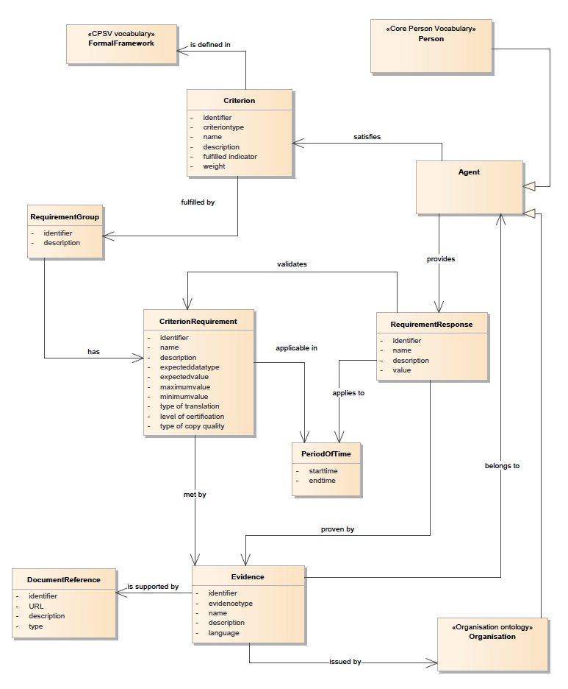
Figure 4 CCCEV Data model

Class: Criterion
The Criterion class represents the rule or principle used to judge, evaluate or assess something. The Criterion class has the properties described below.

Property: identifier
This property provides a formally issued identifier for the Criterion. A Criterion must have an identifier.

Property: criterion type
A Criterion must be defined in terms of a coded type in order to allow for classification and automatic translation. The types of criterion shall be based on controlled vocabularies.

Property: name
A Criterion must have a name. It can be used as a short descriptive text.

Property: description
A Criterion may be textually described using this property. The description can be used to add details and further explanation about the Criterion.

Property: fulfilled indicator
This property is used when the Criterion class is informed as a response and the submitter wants to specify whether the Criterion is considered to be fulfilled (true) or not (false).

Property: weight
A Criterion may have a weight to provide for automatic scoring of the Criterion responses. It implies that there are multiple criteria, and the weight represents the importance of one criterion among the whole set of criteria.

Property: is defined in Formal framework
A legal text or any other Formal framework defines the legal basis for the criterion.

Property: fulfilled by Requirement group
A Criterion shall be fulfilled by means of one or more groups of options. Each one of these options is defined as a Requirements group.

There might be different ways to validate a single criterion, therefore there can be multiple Requirement groups associated with a criterion. Each Requirement group contains all the requirement criteria that must be fulfilled in order to fulfil the whole criterion.

Class: Formal framework
This class and its properties are defined in the Core Public Service Vocabulary Application Profile and may represent legislation, policy, or policies lying behind the rules that govern a criterion.

Class: Requirement group
Criterion requirement group is the set of requirements that must be fulfilled together to validate a criterion.

A Criterion can be satisfied using different options. The Requirement group class is used to wrap the set of criteria requirements that validate a criterion.

All criteria requirements belonging to a requirement group shall be valid for the requirement group to be considered valid.

When there is more than one Requirement group for a Criterion, at least one of them has to be positively validated for the Criterion to be considered fulfilled.

Property: identifier
A Requirement group must be identified.

Property: description
A Requirement group may be textually described using this property. The description can be used to add details and explanation about the Requirement group.

Property: has Criterion requirement
A Requirement group is a collection of Criterion requirements. At least, a Requirement group shall contain one Criterion requirement.

Class: Criterion requirement
A Criterion can be expressed as a set of requirements where every requirement must be valid. A Criterion requirement is an atomic requirement. This can be better explained with the examples in section 6.1, where the criterion is "to be eligible to enter into the cinema to watch a movie", and there are several options to meet this criterion. One option has two Criterion requirements:

- Holding a ticket
- Being older than eighteen

Some criteria can be expressed with several atomic requirements. A Criterion requirement can specify the expected value that the Criterion response has to contain, or a range of threshold values within which the Criterion response has to fit in.

The Criterion requirement may apply to a certain period of time. It also can provide a list of candidate evidences that the responder can use to prove the Criterion requirement.

Property: identifier
A Criterion requirement must have an identifier.

Property: name
A Criterion requirement may have a name by which it can be referred to.

Property: description
A Criterion requirement may have an explanatory description.

Property: expected data type
Each Criterion requirement shall describe the expected data type that the response has to provide.

Property: expected value
This property is used to define the expected value that the responder has to provide in the Criterion response.

Property: maximum value
When the value of the Criterion response must fall into a range or it shall be lesser than a threshold, this property is used to define the maximum expected value.

Property: minimum value
When the value of the Criterion response must fall into a range or it shall be larger than a specific threshold, this property is used to define the minimum expected value.

Property: type of translation
A Criterion requirement may specify whether the evidence proving that this Criterion requirement shall be translated and what type of translation shall apply, for instance, certified translation.

Property: level of certification
A Criterion requirement may specify whether the Evidence proving this Criterion requirement shall belong to a specific level of certification, for instance, legalisation.

Property: type of copy quality
A Criterion requirement may specify whether the Evidence proving this Criterion requirement shall be of a specific type of copy, for instance, certified copy.

Property: applicable in Period of time
If the Criterion requirement shall apply to a specific time period, this class is used to describe it.

Property: met by Evidence
A Criterion Requirement may point to a list of candidate Evidences that can be used by the responder to prove the Criterion requirement is fulfilled.

Class: Requirement response
Requirement response is an assertion that responds to a criterion requirement.

Requirement Response is the class used to define the actual response to a Criterion requirement. It provides the value for the specific requirement and the period to which it applies. It refers to the Criterion requirement that validates.

Property: identifier
A Requirement response must have an identifier.

Property: name
A Requirement response may have a name by which it is referred to.

Property: description
A Requirement response may have an explanatory description.

Property: value
The Requirement response must contain the value that responds to the Criterion requirement. In order to fulfil the Criterion requirement, when there is an expected value or an expected threshold, the value should be equal to the expected value or within the range established by the thresholds.

Property: applies to Period of time
If the Requirement response applies to a specific period, this class is used to establish it.

Property: validates Criterion requirement
The Requirement response must refer to the Criterion requirement it is replying to.

Property: proven by Evidence
The Requirement response may provide the Evidence that proves the response, and thus the Criterion requirement.

Class: Period of time
An interval of time that is named or defined by its start and end times.

Property: start time
The date and time on which the period of time starts.

Property: end time
The date and time on which the period of time finalizes.

Class: Evidence
Evidence is any resource that can document or support a Requirement response.

The Evidence class contains information that proves that a Criterion requirement exists or is true, in particular Evidences are used to prove that a specific Criterion is met.

An Evidence can have the following properties.

Property: identifier
An Evidence must have an identifier.

Property: evidence type
The Evidences contain a property type to categorize Evidences and to allow for the creation of controlled vocabularies that can facilitate automatic translation.

Property: name
An Evidence may have a name by which it is referred to.

Property: description
An Evidence may have an explanatory description.

Property: language
An Evidence may define the language the attestation of evidentiary document is written in.

Property: issued by Organisation
An Evidence may refer to the organisation that issued the attestation or evidentiary document.

Property: is supported by Document reference
An Evidence may refer to the attestation, to the evidentiary document or to the URL where the proof from a third party can be found.

Property: belongs to Agent
An Evidence shall belong to an Agent. A Criterion may affect several Agents; therefore the evidences shall define to which Agent they belong. For instance, a criterion of non-conviction applied to an Organisation requires evidences of non-conviction for the organisation responsible persons. Each of those evidences shall indicate to which person within the organisation they belong.

Class: Agent
An Organisation or Natural person providing a Requirement response that satisfies a Criterion. The Agent class is a generalisation of the Person and Organisation classes defined in the Core Person Vocabulary and the Organisation Ontology respectively.

Property: satisfies Criterion
An Agent satisfies a Criterion. It shall satisfy the Criterion by providing Requirement responses that validate the Criterion requirements of the Criterion.

Property: provides Requirement response
An Agent provides Requirement responses to validate the Criterion requirements defined in the Criterion.

Class: Organisation
This is a subclass of the class Agent. This subclass contains the properties defined in the class Agent above plus the properties defined in the Organisation Ontology.

The modelling of the Legal Entities must follow the Core Business Vocabulary (Legal Entity is a subclass of Organisation) and the modelling of Public Organisations must follow the Core Public Organisation Vocabulary (Public Organisation is a subclass of Formal Organisation)

Class: Person
This is a subclass of the class Agent. This subclass contains the properties defined in the class Agent above plus the properties defined in the Core Person Vocabulary.

Class: Document reference
A reference to the document, attestation or data, usually provided by a party different from the one providing the response, that proves the response.

Property: identifier
A Document reference shall contain an identifier.

Property: URL
The Uniform Resource Locator where the document or attestation can be found.

Property: description
A Document reference may contain the description of the attestation or evidentiary document.

Property: type
The Document reference may contain the type that categorizes the attestation or evidentiary document.

RDF distribution of the CCCEV
The RDF distribution of the Core Criterion and Core Evidence Vocabulary is available at the Core Vocabularies Registry in the following link: http://data.europa.eu/m8g.

Examples
This section provides some examples of criteria and evidences for illustration purposes.

Simple examples
This section contains a set of simple examples that illustrate the use of the CCCEV data model. These simple examples explain how to get admitted to a movie in a cinema.

The first scenario describes the usual way to enter into the cinema, having paid an entry fee. In this first example there is a single requirement and a single evidence. Using the CCCEV, the scenario could be depicted with the following elements:

The cinema owner establishes the criterion:

- Criterion: Entitlement to enter.
- Requirement group: First option
  - Criterion requirement: To hold a ticket.

The person willing to see the movie has to prove he fulfils the requirement:

- Requirement response: I have paid the fee and I have got a ticket
  - Evidence: The actual ticket

This is the simplest example where there is a single option.

A second scenario describes an additional way to get admitted into the cinema: There is a free entrance for accredited members of the press. In this case, you have two options, either you have paid the ticket or you can demonstrate you are an accredited member of the press.

The criterion has now changed to support two different options. The options are packaged in different groups, and the person willing to enter into the cinema has to provide a response and evidences on one of them.

- Criterion: Entitlement to enter.
- Requirement group: First option
  - Criterion requirement: To hold a ticket.
- Requirement group: Second option
  - Criterion requirement: To be accredited as a member of the press

The person willing to see the movie has to prove he fulfils one requirement group or the other. For instance, he can demonstrate he is an accredited member of the press:

- Requirement response: I am member of the press and I have an accreditation.
  - Evidence: The press accreditation

In this case, the person will enter the cinema because he fulfils the second option even if he does not hold a ticket.

The third scenario adds yet another requirement. The movie is not allowed for people under eighteen. In this case, there is another requirement that has to be fulfilled.

- Criterion: Entitlement to enter.
- Requirement group: First option
  - Criterion requirement: To hold a ticket.
    - Candidate evidence: The ticket
  - Criterion requirement: To be over eighteen
    - Candidate evidence: ID card
    - Candidate evidence: Passport
- Requirement group: Second option
  - Criterion requirement: To be accredited as a member of the press
    - Candidate evidence: Press accreditation
  - Criterion requirement: To be over eighteen
    - Candidate evidence: ID card
    - Candidate evidence: Passport

In this case, the first option has two different criteria that must be fulfilled at the same time: The person must have the ticket and has to be over eighteen. The example of the criterion includes a new concept, the candidate evidences, where the cinema owner describes which elements can be used to prove each criterion requirement.

- Requirement response: I have paid the fee and I have got a ticket
  - Evidence: The actual ticket
- Requirement response: I am 23 years-old
  - Evidence: The ID card

This last example depicts the most complex example, where there are different options to fulfil the criterion, and one of the options has more than one requirement.

Exclusion criterion
This example describes an exclusion criterion as it can be found in a procurement process. The example populates the properties for the classes of the CCCEV model to illustrate their use. Each section below defines the contents of one of the classes of the CCCEV data model.

Criterion
The criterion establishes that the organisations participating in a criminal organisation shall be excluded from the tendering process except if they can provide evidences that they have demonstrated self-cleaning.

The table below contains the Criterion properties for this class:

Property | Value
Identifier | 005eb9ed-1347-4ca3-bb29-9bc0db64e1ab
Criterion Type | Exclusion.Criminal_conviction
Name | Participation in a criminal organisation
Description | The economic operator itself or any person who is a member of its administrative, management or supervisory body or has powers of representation, decision or control therein has not been the subject of a conviction by final judgment for participation in a criminal organisation, by a conviction rendered at the most five years ago or in which an exclusion period set out directly in the conviction continues to be applicable. As defined in Article 2 of Council Framework Decision 2008/841/JHA of 24 October 2008 on the fight against organised crime (OJ L 300, 11.11.2008, p. 42).
Formal framework | See 6.2.2
Requirement group | See 6.2.3

The coded type contains a value from an eventual controlled vocabulary that could be used to ensure the criterion can be translated to different languages.

Formal framework
In electronic public procurement, the legislation drives the exclusion criteria. The legislation is described using the Formal framework class. This example describes the EU Directive 2014/24/EU.

Property | Value
Identifier | 005eb9ed-1347-4ca3-bb29-9bc0db64e1ab-000211
Name | DIRECTIVE 2014/24/EU OF THE EUROPEAN PARLIAMENT AND OF THE COUNCIL of 26 February 2014 on public procurement and repealing Directive 2004/18/EC
Description | Directive 2014/24/EU
Language | English
URI | http://eur-lex.europa.eu/legal-content/EN/TXT/?uri=celex:32014L0024
Territorial application | Europe
Jurisdiction level | EU_DIRECTIVE

Requirement group

The requirement group class contains an identifier and a set of criterion requirements.

The requirement group represents an option. In our example, there are two different option and their properties will be an identifier and a set of Criterion requirements that describe each option:

Property | Value
Identifier | 7c637c0c-7703-4389-ba52-02997a055bd7
Description | Not been subject to conviction.
Criterion requirement | See 6.2.4.

Criterion requirement
Each requirement group has one or more criterion requirements. In this example, the first requirement group contains only one requirement.

This first Requirement Group is the option that has to be chosen by the parties that have never been convicted. In this case, replying "true" to this criterion requirement is enough to fulfil the whole criterion.

Property | Value
Identifier | 4157c56b-754b-4f92-b4b1-0256b9a472d2
Name | The economic operator has not been the subject of a conviction.
Description | The economic operator itself or any person who is a member of its administrative, management, or supervisory board or has powers of representation, decision or control therein has not been the subject of a conviction by final judgement for participation in a criminal organisation, by a conviction rendered at the most five years ago or in which an exclusion period set out directly in the conviction continues to be applicable as defined in Article 2 of Council Framework Decision 2008/841/JHA of 24 October 2008 on the fight against organised crime (OJ L 300, 11.11.2008, p. 42)
Expected data type | Boolean

The second requirement group contains a set of six different criterion requirements that may also be used to make the whole criterion valid. Those parties that having been convicted, have cleared it up shall use this option.

Most of the requirements are provided textually, which means that it will not be possible to automatically assess the responses.

Property | Value
Identifier | 4157c56b-754b-4f92-b4b1-0256b9a472d1
Name | The economic operator has been the subject of a conviction.
Description: | The economic operator itself or any person who is a member of its administrative, management, or supervisory board or has powers of representation, decision or control therein has been the subject of a conviction by final judgement for participation in a criminal organisation, by a conviction rendered at the most five years ago or in which an exclusion period set out directly in the conviction continues to be applicable as defined in Article 2 of Council Framework Decision 2008/841/JHA of 24 October 2008 on the fight against organised crime (OJ L 300, 11.11.2008, p. 42)
Expected data type | Boolean

Property | Value
Identifier | ecf40999-7b64-4e10-b960-7f8ff8674cf6
Name | Date of conviction
Description | Provide the date of conviction
Expected data type | text

Note that the criterion requirements define the expected data type as text data.

Property | Value
Identifier | 7d35fb7c-da5b-4830-b598-4f347a04dceb
Name | Reason of the conviction
Description | Provide the reason of the conviction
Expected data type | text

Property | Value
identifier | c5012430-14da-454c-9d01-34cedc6a7ded
Name | Name of the convicted persons
Description | Provide the name of the convicted persons.
Expected data type | text

Property | Value
Identifier | 9ca9096f-edd2-4f19-b6b1-b55c83a2d5c8
Description | Length of the period of conviction
Expected data type | text

Property | Value
Identifier | 41dd2e9b-1bfd-44c7-93ee-56bd74a4334b
Description | Have measures been taken to demonstrate the self-cleaning?
Expected data type | Boolean

Property | Value
Identifier | 7b07904f-e080-401a-a3a1-9a3efeeda54b
Description | Description of the measures taken to demonstrate "self-cleaning".
Expected data type | text

Requirement response

In this example, the persons replying to the criterion can use two different options:

      - Use the first requirement group and state that they have not been convicted, or

      - Fail the first requirement group as someone has been convicted but still provide enough additional information so the criterion can be considered as valid.

In case the responder fulfils the initial requirement group, the requirement response will be:

Property | Value
Response identifier | 3242-3432-45565-b4i942
Validates Criterion requirement identifier | 4157c56b-754b-4f92-b4b1-0256b9a472d2
Description | The economic operator itself or any person who is a member of its administrative, management, or supervisory board or has powers of representation, decision or control therein has not been the subject of a conviction by final judgement for participation in a criminal organisation, by a conviction rendered at the most five years ago or in which an exclusion period set out directly in the conviction continues to be applicable as defined in Article 2 of Council Framework Decision 2008/841/JHA of 24 October 2008 on the fight against organised crime (OJ L 300, 11.11.2008, p. 42)
Value | true

The recipient of the criterion response will be able to automatically assess the reply when the above requirement group is met.

If the responder does not fulfil the initial requirement group, he will reply with the following requirement responses associated with the requirement criterion of the second requirement group.

Property | Value
Response identifier | 3242-3432-45565-b4i943
Validates Criterion requirement identifier | ecf40999-7b64-4e10-b960-7f8ff8674cf6
Description | The economic operator itself or any person who is a member of its administrative, management, or supervisory board or has powers of representation, decision or control therein has been the subject of a conviction by final judgement for participation in a criminal organisation, by a conviction rendered at the most five years ago or in which an exclusion period set out directly in the conviction continues to be applicable as defined in Article 2 of Council Framework Decision 2008/841/JHA of 24 October 2008 on the fight against organised crime (OJ L 300, 11.11.2008, p. 42)
Value | true

Property | Value
Response identifier | 3242-3432-45565-b4i944
Validates Criterion requirement identifier | 7d35fb7c-da5b-4830-b598-4f347a04dceb
Description | Provide the date of conviction
Value | 2013-01-01

Property | Value
Response identifier | 3242-3432-45565-b4i946
Validates Criterion requirement identifier | c5012430-14da-454c-9d01-34cedc6a7ded
Description | Provide the reason of the conviction
Value | This economic operator was accused and convicted of Espionage in Buenos Aires by an Argentinian Court.

Property | Value
Response identifier | 3242-3432-45565-b4i948
Validates Criterion requirement identifier | 7d35fb7c-da5b-4830-b598-4f347a04dceb
Description | Provide the name of the convicted persons.
Value | The convicted party was the ACME's branch in Buenos Aires.

Property | Value
Response identifier | 3242-3432-45565-b4i950
Validates Criterion requirement identifier | c5012430-14da-454c-9d01-34cedc6a7ded
Description | Length of the period of conviction
Value | Till the end of the year 2013

Property | Value
Response identifier | 3242-3432-45565-b4i952
Validates Criterion requirement identifier | 7d35fb7c-da5b-4830-b598-4f347a04dceb
Description | Have measures been taken to demonstrate the self-cleaning?
Value | true

Property | Value
Response identifier | 3242-3432-45565-b4i954
Validates Criterion requirement identifier | c5012430-14da-454c-9d01-34cedc6a7ded
Description | Description of the measures taken to demonstrate "self-cleaning".
Value | We repealed the decision in front of an International Court. This Court decided that ACME was innocent. See evidences attached.
Evidence | See 6.2.6

In case the first requirement group is not met, then the recipient of the response will have to manually assess the textual responses provided to each criterion requirement in the second requirement group.

The last response to the final criterion requirement points to an evidence, other requirement responses should contain also the proper evidences in order to prove the response.

Evidence
The example uses an evidence to prove the last response provided.

The evidence points to a court decision from the Argentinian Justice and refers to the place where this evidence can be actually found. The properties of the evidence are as follows:

Property | Value
Evidence identifier | 3242-3432-45565-b4i954
Evidence type | Court decision
Name | Court decision
Language | Spanish
Supported by Document reference | See 6.2.7

Document reference
The evidence points to a reference that in this case is a URL to a Court decision.

Property | Value
identifier | 2323-3432-3864-3423
URL | http://www.dipublico.org/jurisprudencia/internacional/corte-permanente-de-justicia-internacional/
Description | Resolution of the argentinian court.
type | mime-pdf

Selection criterion
This second complex example describes a selection criterion that can be found in a procurement process. The criterion establishes that the turnover for the last three fiscal years has to be more than a certain minimum threshold and that it has a weight of 60% of the total score.

Criterion
The criterion defines its weight. As in the previous case, the coded type could be used to identify the type of criterion in order to allow for automatic translation into different languages.

Property | Value
Identifier | 499efc97-2ac1-4af2-9e84-323c2ca67747
Criterion Type | Selection.Economic_Financial_Standing
Name | General yearly turnover
Description | The economic operator's general yearly turnover for the last three financial years.
Weight | 60%
Requirement group | See 6.3.2

Requirement group
In this example, there is only one requirement group as there are no options, and every requirement in the group will contain a criterion requirement defining the minimum threshold value for the turnover and the period this maximum should be applied to.

Property | Value
Identifier | 5cff730f-cc50-4177-b2d9-107eb40a686c
Description | Threshold for yearly turnover
Criterion requirement | See 6.3.3.

Criterion requirement
There are three different criterion requirements in this requirement group. One per each fiscal year, and they have both a minimum threshold value and an applicable period.

Property | Value
Identifier | 4157c56b-754b-4f92-b4b1-0256b9a472d2
Description | Minimum financial turnover in Euros for 2013.
Expected data type | Numeric
Minimum value | 100000
Applicable in period | See 6.3.4

Property | Value
Identifier | 57cd25e9-a04f-45fa-a964-1dad9ee8335a
Description | Minimum financial turnover in Euros for 2014.
Expected data type | Numeric
Minimum value | 150000
Applicable in period | See 6.3.4

Property | Value
Identifier | 0892e478-84f7-4dd7-b098-a75dfea30e85
Description | Minimum financial turnover in Euros for 2015.
Expected data type | Numeric
Minimum value | 200000
Applicable in period | See 6.3.4

These three criterion requirements provide a minimum expected value per each fiscal year.

Period
Each criterion requirement has an applicable period. Similarly, the requirement response also refers to the applicable period. The Period class is used to define the financial year the requirement has to be applied to or belongs to respectively.

The table below describes as an example the Period class defining the financial year 2015.

Property | Value
Start time | 2015-01-01 08:00
End time | 2015-12-31 21:00

Requirement response
In this example, there are three response requirements, one per each criterion requirement. Every requirement response describes the turnover per each year.

Property | Value
Identifier | 3242-3432-45565-b4i943
Validates Criterion requirement Identifier | 4157c56b-754b-4f92-b4b1-0256b9a472d2
Description |  | Minimum financial turnover in Euros for 2013
Value | 178000
Applies to period |  | See 6.3.4

Property | Value
Identifier | 3242-3432-45565-b4i944
Validates Criterion requirement Identifier | 57cd25e9-a04f-45fa-a964-1dad9ee8335a
Description | Minimum financial turnover in Euros for 2014
Value | 298000
Applies to period | See 6.3.4

Property |  | Value
Identifier |  | 3242-3432-45565-b4i946
Validates Criterion requirement Identifier |  | 0892e478-84f7-4dd7-b098-a75dfea30e85
Description | Minimum financial turnover in Euros for 2015
Value |  | 344000
Applies to period |  | See 6.3.4

The recipient of the response will be able to automatically assess whether the values are higher than the minimum threshold established in the criterion and thus will be able to automatically score the response.

Conformance Statement
A data interchange, however that interchange occurs, is conformant with the CCCEV if:
- it uses the terms (classes and properties) in a way consistent with their semantics as declared in this specification;
- it does not use terms from other vocabularies instead of ones defined in this vocabulary that could reasonably be used.

A conforming data interchange:
- may include terms from other vocabularies;
- may use only a subset of CCCEV terms.

A CCCEV application profile is a specification for data interchange that adds additional constraints. Such additional constraints in a profile may include:
- a minimum set of required terms;
- classes and properties for additional terms not covered in the CCCEV;
- controlled vocabularies or URI sets as acceptable values for properties.

The CCCEV is technology-neutral and a publisher may use any of the terms defined in this document encoded in any technology although RDF and XML are preferred.

Accessibility and Multilingual Aspects
The CCCEV can operate in any language as:
- In a multilingual context, all properties with a datatype “Text” where the value for that property may exist in multiple languages, the property may have multiple instances that are tagged with a language identifier for each language in which the value for that property exists.
- The specification strongly encourages the use of URIs as identifiers and all URIs are 'dumb strings'. Although they clearly make use of English words, they do not convey those words - that is done by the human-readable labels which can be multilingual.
- The acronym URI is used throughout the document due to widespread familiarity. However, Internationalised Resource Identifiers (IRIs) are equally usable, and these can use any character in any script.
Translations of the labels used in the various terms can readily be added to the schema (please contact the working group if you can help with this).

References

[1] | E. Europa, “Commission further simplifies public procurement across the EU,” 6 January 2016. [Online]. Available: http://ec.europa.eu/growth/tools-databases/newsroom/cf/itemdetail.cfm?item_id=8611.
[2] | “EC Europa: EUROPEAN SINGLE PROCUREMENT DOCUMENT SERVICE,” [Online]. Available: http://ec.europa.eu/isa/documents/actions/more-about-action-2.16_en.pdf.

http://dublincore.org/documents/dcmi-terms/
http://www.cenbii.eu/about-cen-wsbii/
https://joinup.ec.europa.eu/asset/core_person/description
http://ec.europa.eu/isa/isa2/index_en.htm
http://ec.europa.eu/isa/isa2/index_en.htm
https://joinup.ec.europa.eu/node/148214
https://joinup.ec.europa.eu/asset/core_public_service/description
http://dublincore.org/documents/2012/06/14/dcmi-terms/
https://www.w3.org/TR/vocab-org
https://www.w3.org/2011/gld/wiki/ORG_Implementations
https://joinup.ec.europa.eu/asset/core_public_service/description
https://www.w3.org/TR/vocab-org/
https://joinup.ec.europa.eu/asset/core_person/description
http://www.ietf.org/rfc/rfc3987.txt

